**SMART FAN SYSTEM FAN SYSTEM USING DHT SENSOR**

A PROJECT REPORT

***Submitted by***

BL.EN.U4AIE19013 K.CHARAN TEJ

BL.EN.U4AIE19014 CHAVALI SURYA TEJA

BL.EN.U4AIE19058 M.C. SANDEEP PREETHAM

BL.EN.U4AIE19064 T.ROHITH

***in partial fulfillment for the award of the degree***

***0f***

**BACHELOR OF TECHNOLOGY**

IN

COMPUTER SCIENCE ENGINEERING



AMRITA SCHOOL OF ENGINEERING, BANGALORE

AMRITA VISHWA VIDYAPEETHAM

**BANGALORE 560 035**

JUNE-2020

**AMRITA VISHWA VIDYAPEETHAM**

**AMRITA SCHOOL OF ENGINEERING, BANGALORE, 560035**



**BONAFIDE CERTIFICATE**

This is to certify that the project report entitled “ **SMART FAN SYSTEM USING DHT SENSOR “** submitted by

K.CHARAN TEJ BL.EN.U4AIE19013

CHAVALI SURYA TEJA BL.EN.U4AIE19014

M.C.SANDEEP PREETHAM BL.EN.U4AIE19031

T.ROHITH BL.EN.U4AIE19064

in partial fulfillment of the requirements for the award of the **Degree Bachelor of Technology** in “**COMPUTER SCIENCE** Engineering " is a bonafide record of the work carried out under my(our) guidance and supervision at Amrita School of Engineering, Bangalore.

NAME OF SUPERVISOR NAMEOF CO- SUPERVISOR

<<Designation>> << Designation>>

<<Department>> <<Department>>

<<Signature of the Chairperson of the Department with date>>

NAME OF CHAIRPERSON-……..

This project report was evaluated by us on ……… (Date...)

INTERNAL EXAMINER EXTERNAL EXAMINER

ABSTRACT

This abstract tells us about the design and simulation of Humidity and Temperature Detection using the DHT 11 sensor.

This deals with how we calculate the humidity and the temperature of the surroundings.

The objective of the report is to achieve a functional system in terms of hardware and software, to measure the temperature and humidity. Monitoring the humidity and temperature, we have an automatic DC fan that works on the higher temperature and humidity.

An Arduino board with interfacing a sensor placed in an environment to measure the temperature and the humidity. And using the development of board for the communication with the sensors, the LCD, and the fan. We will implement a program that allows the requirements.

The sensors will show the Temperature and the Humidity where the data will be uploaded in the Arduino, with the code the data will be shown in the LCD which is connected to Arduino. If the temperature and humidity go above the fixed level, automatically the fan which is connected will be ON.

TABLE OF CONTENTS

**Chapter 1 - Introduction**…………………………….……………………………..…..8

* 1. Smart Fan System Using DHT Sensor…………………………………….….9

1.1.A. Arduino UNO ……………..……………….……….….………..………..9

1.1.B. DHT temperature & humidity sensor ………….………………….…..….9

1.1.C. LCD ……………………………….……………………………………..10

**Chapter 2 - Designing**…………………………………………….…………………….11

2.1 Hardware …………………….………………….………………...……..............11

2.2 Simulation …………………….………………….………………...……............12

2.3 Code……………………………………………………………………………...14

**Chapter 3** - **Result**……………………………………………………..………………..16

**Chapter 4 - Conclusion**…………………......................................................................16

**REFERENCES**………………………………………………………...………………………..17

LIST OF FIGURES

Fig 1.1 .a. – Arduino UNO ……………………………………………………….……………….8

Fig 1.1 .b. – DHT 11 Sensor ………………………………………………………...…………….9

Fig 1.1 .c. – LCD (16 x 2 )….. …………………………………………………….……..………10

Fig 2.1 Circuit Diagram **……………………………….…………………….............................**12

Fig 2.2 Circuit Diagram **….……………………………………………….…………...….……**12

Fig 2.3 Arduino PIN Connections **….……………………………………………………….…**13

Fig 3.1 – Simulation ( Fan On )…………………………………………………………...….…..16

Fig 3.2 – Simulation ( Fan Off )…………………………………………………………..….…..16

LIST OF TABLES

Table 1: Components specifications……………………………………………8

INTRODUCTION

In the world, these airflow systems which require special attention, especially when the room is heated, When it is necessary to be in the constant temperature and humidity to have the desired comfort. The data we get from the board can achieve a system that will allow monitoring temperature and humidity in the room.

For data acquisition board, an Arduino board. the advantages are :

* The board is an open-source
* Easily programmed
* Can be used on any operating system
* Low cost

The Arduino can be programmed easily using the IDE. The program will be loaded on the board. In this project, we used Arduino UNO. The difference between the Arduino and other boards is that this board does not use a drive FTDI USB to serial chip.

Measurement and maintaining constant temperature is important in various industrial processes. In electrical measurements, we use Temperature transducers for a wide range of temperatures and because of the measurement accuracy in a specific area.

Humidity is the amount of water vapor that is contained in the air. it is very important for both air in the teams of weather in the terma of bioclimatic.

Humidity is expressed as follows:

• Absolute humidity:

𝑈𝑎=𝑚ℎ−𝑚𝑢

𝑚𝑢 100 [%]

• Relative humidity :

𝑈𝑟=𝑚ℎ−𝑚𝑢

𝑚ℎ 100 [%]

* 1. Smart Fan System Using DHT Sensor

There are three main components in a smart fan system using the DHT sensor. These are Arduino UNO, DHT sensor, LCD.

1.1.A) Arduino UNO

It is an open-source microcontroller board based on the Microchip ATmega328P microcontroller. It consists of sets of digital & analog input/output pins.

It has a total of 28pins. In which 14 are digital input or output pins & six are analog pins that can be used for the interaction with electronic components like sensors and motors; 3 Ground pins and the remaining pins for 3.3V, 5V, VIN, RESET and AREF (Analogue Reference). It contains a microcontroller with the 32KB storage memory, 2 KB of static RAM, and 1 KB of EEPROM (i.e Electrically Erasable Programmable Read-Only Memory). Arduino Uno supports C programming. It also has 16 megahertz ceramic resonators, a USB connection jack for connecting with PC, a jack for external power supply, an ICSP header, a reset button to reset to factory setting. The input voltage lies between 7V to 12V.

|  |  |  |  |
| --- | --- | --- | --- |
| SL.No. | Component Name | Specifications | Quantity |
| 1. | Arduino UNO | 1 |  |
| 2. | DHT sensor | 1 | 3.5 to 5.5v |
| 3. | Wires | As required |  |
| 4. | LCD | 1 | Red, Yellow, Green |
| 5. | DC fan | 1 |  |

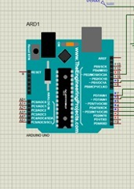

Figure (1.1a)

1.1.B) DHT Temperature & Humidity Sensor

DHT11 is a basic low budget digital humidity and temperature sensor. These sensors are usually made up of either polymers or semiconductor ceramics. it can be easily interfaced with any microcontroller board. it has simple controls. DHT11 mainly consists of the two elements, capacitive humidity sensing elements for measuring the humidity and a thermistor for measuring the temperature. To measure humidity, the capacitor has two electrodes which consist of a moisture-holding substrate as a dielectric between the two electrodes. The difference in the capacitive value occurs with the change in humidity levels.

Accordingly for measuring, the temperature DHT11 uses a negative temperature coefficient thermistor, which results in a decrease in it is resistance value with the increase of the temperature.

The operating voltage of this sensor lies form 3.5v to 5.5 v. The range of the temperature and humidity of DHT11 is 0 to 50 degrees Celsius with a 2-degree accuracy and 20% to 80% with 5% accuracy respectively.

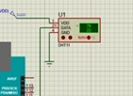

Figure (1.1b)

1.1.C) LCD

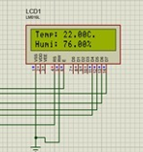 LCD – liquid crystalline materials used in the LCD (liquid crystal display ). these don't emit light directly. LCD used the same basic technology, except that the arbitrary image is made from a matrix of small pixels. LCD can be either be normally on or off, it depends on their polarizer arrangement. LCD screens do not use phosphors, they will rarely suffer image burin when a static image is in the display for a long time of use. A twisted nematic liquid crystal is used.

Figure(1.1c)

DESIGNING

2.1) Hardware:-

Based on the idea of our project is solving, we will be designing a system that will be having a Proximity infrared sensor as the main component. This sensor is placed on the road after every particular distance. This sensor will emit electromagnetic radiation and when some radiation or wave is returned, it is sent to the Arduino UNO microcontroller, from which we can say that there is an obstacle, which in our case is a vehicle.

All the sensors that have been placed will be sending the result at regular intervals of time. Based on from which sensor we got the waves back, the duration for the changing of signals from red to green or green to red or no change in signal will be decided and the traffic lights will be working accordingly. That is if from some particular way we get more waves returned, which means that many sensors have got their waves returned then congestion at that is more. So to clear that way more time for a green signal will be given

2.2) Simulation:-

The design that we are designing for this project is designed using Proteus 8 Professional simulation software. We have used Arduino UNO, DHT 11 sensor, LCD, and DC fan . in the design we have an input voltage with is connected to the sensor, and here the sensor will calculate the humidity and temperature of the room, and the data will be transferred to the Arduino board. and as per the given code to the board, it will be displayed in the LCD which is connected to the Arduino.

With the temperature and the humidity . with Arduino code and the given condition, above 30 c temperature, the DC fan which is connected with the Arduino automatically gets on by the surrounding.

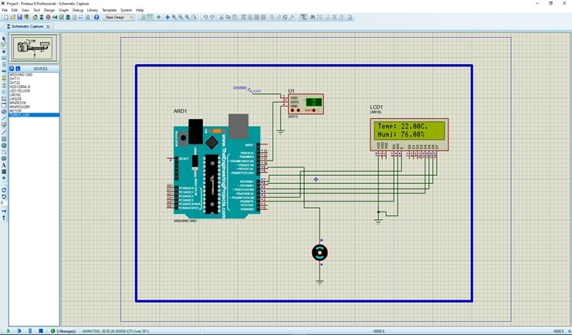

Figure(2.1)

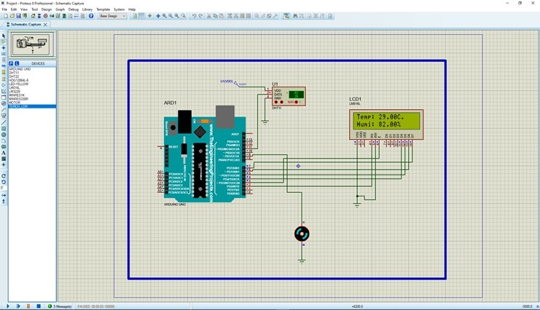

Figure(2.2)

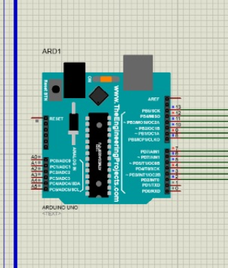

Figure (2.3)

2.3 ARDUINO CODE

# include "DHT.h" //DHT library

# define DHTPIN 11 //DHT pin

# define DHTTYPE DHT11

DHT dht(DHTPIN, DHTTYPE);

# include "LiquidCrystal.h" // lcd library

int rs = 2, en = 3, d4 = 4, d5 = 5, d6 = 6, d7 = 7;

LiquidCrystal lcd(rs, en, d4, d5, d6, d7);

int FAN = 9;

float t; // temperature in celcius

float h; // humidity in percentage

void setup(){ //setup

Serial.begin(9600);

pinMode(FAN,OUTPUT);

dht.begin();

lcd.begin(16, 2);

lcd.setCursor(0, 0);

lcd.print(" Done by ");

lcd.setCursor(0, 1);

lcd.print(" Team 12... ");

delay(2000);

lcd.clear();

}

void loop() //loop

{

h = dht.readHumidity() ;

t = dht.readTemperature();

lcd.setCursor(0, 0);

lcd.print("Temp: ");

lcd.print(t);

lcd.print("C.");

lcd.setCursor(0, 1);

lcd.print("Humi: ");

lcd.print(h);

lcd.print("% ");

if(h >=82 || t>=30)

{

digitalWrite(FAN,HIGH);

}

else

{

digitalWrite(FAN,LOW);

}

delay(500);

delay(500);

}

RESULT AND ANALYSIS

3.1 Analysis:-

In the simulation part, The sensor gets input voltage and after it is analysis the sensor will get the temperature and humidity and data is sent to the board . with the code given the Arduino will intake the data and with the connection of the LCD, the data will be shown in LCD. By the given code, if it goes above a fixed temperature and humidity the DC fan will automatically run which was connected to the Arduino.

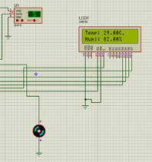

Figure(3.1) (fan on)

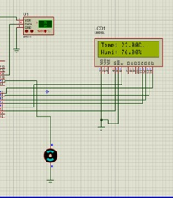

Figure(3.1) (fan off)

CONCLUSION

Temperature and humidity measurement is essential to talk about the control of the environment (system) . in this function system, hardware and software enable us, temperature, and the humidity measurement of the enclosure.

The accuracy of the measurement system is 0.5 c for the temperature and 1% for the moisture. The result was displayed on an LCD. This LCD can display 16 characters on the two lines. They were created and displayed on the LCD both temperature and humidity.

REFERENCES

1. <https://www.researchgate.net/publication/323713954_Automatic_Speed_Control_and_Turning_ONOFF_for_Smart_Fan_by_Temperature_and_Ultrasonic_Sensor>
2. <https://iopscience.iop.org/article/10.1088/1757-899X/325/1/012022/pdf>
3. <https://www.researchgate.net/publication/330511595_Smarty_Smart_Fan>